**PRACTICAL-8**

**SUBJECT:** **Embedded Programming**

**SUBJECT_CODE:** **CAT-851**

**UIC DEPARTMENT**

**8.Write a program to control pi camera using Raspberry pi over internet**

Ans:

**Step 1: Create your domain name**

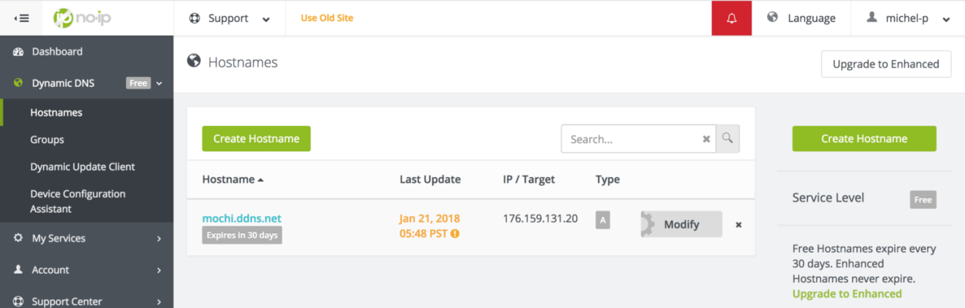

After subscribing, in the dashboard, simply go in the “Dynamic DNS” section. Then “Create Hostname”. Choose a name on the next screen, let the options by default and validate. Now let’s go back on our Pi!

**Step 2: Install the no-ip script on your PI**

Let’s download the script from no-ip first. On the Raspberry PI terminal:

**Configuring your internet box**

* Connect to router administration panel
* Configure the port forwarding to your PI

Code:

import urllib

import cv2,time

import numpy as np

first_frame = None

url= ’http://192.168.2.52:8080/shot.jpg’

imgResp = urllib.urlopen(url)

imgNp = np.array(bytearray(imgResp.read()),dtype=np.uint8)

img = cv2.imdecode(imgNp,-1)

cv2.namedWindow(‘image’,cv2.WINDOW_NORMAL)

cv2.resizeWindow(‘image’,600,600)

i=0

while True:

imgResp=urllib.urlopen(url)

imgNp=np.array(bytearray(imgResp.read()),dtype=n.uint8)

img=cv2.imdecode(imgNp,-1)

cv2.imshow(‘image’,img)

cv2.imwrite(‘test.jpg’’,img)

key=cv2.waitKey(1)

if key==ord(‘q’):

break

cv2.destroyAllWindows

**OUTPUT:**

